  Hard of Hearing Hackathon **BASIRI APP**

https://lh4.googleusercontent.com/gNQcSmiew4Lye7oOIlwdXWtoSWSlhnaXCHJbxzf2mkhh-pDmLTgJLbkXF3EA3Jdc3XKROMVA36f2AQnTRzluVAE2imMprsgyeQ6-o1eOMD-9Sc97DwWRZWh5WuggCmyDaU_EXrHf

Sabah Tartir

Dania Nazzal

Amal Zaqqa

Noorudin Nimer

4th March 2022

**Introduction**

Hard of hearing: people who have mild to severe hearing loss and could benefit from a cochlear implant, hearing aid, and usually communicate by using spoken language. On the other hand, Deaf people are those who have profound hearing loss and usually communicate by using sign language (1). The World Health Organization (WHO) reported that one in every five individuals, or 1.5 billion people, have some degree of hearing loss in 2021. One-third of those need hearing health care intervention. and 80 percent live in low- and middle-income countries. Even though hearing loss is common worldwide, only a small percentage of persons who may benefit from hearing healthcare obtain services. (2). For those who need a hearing aid, Grundfast and Liu reported that the percentage of hearing aid users is 33% (3). According to more recent research demonstrate that the percentage is closer to 17% and could be significantly less in low- and middle-income areas (4).

**Purpose and motivation**

Adults with hearing loss could experience social isolation as a result of impaired communication, decrease job and educational opportunities, decrease self-esteem and confidence causes emotional problems. On the other hand, there are a lot of hearing aid problems faced by the users such as volume control, butteries life, hearing aid broken and lost. The reasons behind inadequate hearing care services could be attributed to the Cost of services, reduce clinical providers/specialized services, travel inconveniency, communication obstacles (4). Due to a lack of local providers and the difficulties of higher expense and travel, rural children are less likely to begin speech therapy after initial diagnosis and may experience challenges to getting rehabilitation care. (5)

**Purposes of the application:**

1. Make the hearing experience more satisfying with good clarity
2. Give voice to Deaf and speechless
3. Reduce the financial cost
4. Overcoming the difficulties faced by hard of hearing or deafness in specific conditions.
5. Add unique, new, and different features to the present latest technology
6. Access hearing service quick and easy
7. Activate the emergency feature
8. Enabling users to rate how well they understand each other.
9. Connect hearing aid to the user’s phones, computer via Bluetooth during (calls, movies)
10. Tele practice &teleaudiology: use of telecommunications technology to deliver speech-language pathology and audiology services remotely.
11. Book an appointment for a specific hearing solution center or online via telepractice.

**How does the application work?**

BA-SIRI is a communication and utility app that simplifies communication between people who have hard of hearing with others, as well as offers various QoL (Quality of Life) features.

BA-SIRI provides chances for those who are deaf or hard of hearing who know sign language to convert sign language to subtitles(text), voice to make calls, in addition to the ability to use sign language to text or search by converting it to text. also, when the individual is in a meeting or lecture and has difficulty in hearing, BA-SIRI offers subtitles to voice via communication access real-time translation. in the case of deafness and speechless individuals, it gives them opportunities to grab the attention of other individuals by using either Callout feature to grab the attention of individuals, using either sample from the included audio library, text-to-speech, or record samples as needed, with adjustable volume displayed as the radius (whether metric or imperial).On the other hand, to overcome obstacles that may face hard of hearing individuals like difficulty hearing specific conditions clearly we offer options in the application to Detect and amplify audible frequency spectrum or specific ranges of the spectrum for controllable time intervals (for example, amplification of human voice whether male or female during online conferences or pre-recorded samples like the ring of a bell). In addition to a user-friendly interface that allows for control over the various frequency ranges (has to room for upgradability). The application is provided with a system to increase the level of comprehension by enabling users to rate how well they understand each other. it gives A periodic notification (6 months) to remind users of their next checkup to adjust hearing aid fitting for a better hearing experience. As well as, the application lets the users know the location of the hearing aid supplement by activating the GPS feature to better find needed as soon as possible. And allow the users to book an appointment online by choosing the available date in order to meet his hearing services in the clinic. Golden features have been added to the application to overcome the optical of reduced clinical providers/specialized services in a remote area and to overcome barriers which present since the COVID-19 pandemic are a telepractice and teleaudiological option which allow the users to access speech-language pathology and audiological services from anywhere in the worlds. The clients select needed specialists (ENT, Audiologist, speech therapist) and the needed services (fitting hearing aid, PTA, AVT session, speech therapy). In an available appointment. the research indicates that fitted clothes can reduce the intensity of sounds by 19–27 dB relative to the no-mask condition for frequencies above 2 kHz (6). As a result, headscarf, hat, and mask programmers were added to the application. In addition to other programs such as wind and crowd. Also, the users can listen to cell phone calls, movies by hearing aid directly via Bluetooth. Finally, in order to save the lives of those people, emergency calls were added to the application by giving pre-announcement to the target destination like (ambulance, police) that the person who calls has hearing loss.

**How was the application developed?**

BA-SIRI developed according to human-centered design by making some interviews with people who have a hard of hearing and developing many prototypes to fit the output we got from them to get out with this output.

Adobe XD was the main design platform in this project as it fast & powerful UI/UX design solution for websites, apps & more.

**How to use the application?**

The application is designed to be friendly to the largest number of users, so that the user can access the services in an easy way, it gives the possibility to use without creating an account, although creating one gives the user the ability to use any of the features without limitation. For example, If the user does not create an account he will not be able to use the emergency call feature, because the application does not contain his personal information that prove his identity.

When you download and open the app, the following frame appears.

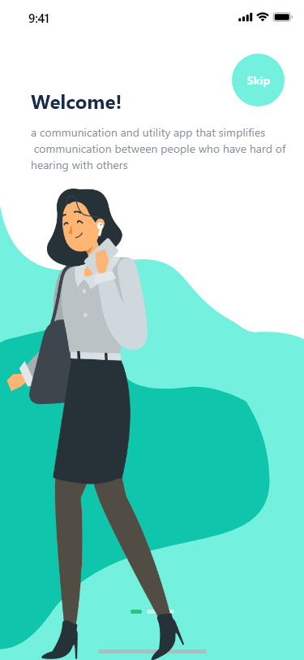

* **Create an account:**

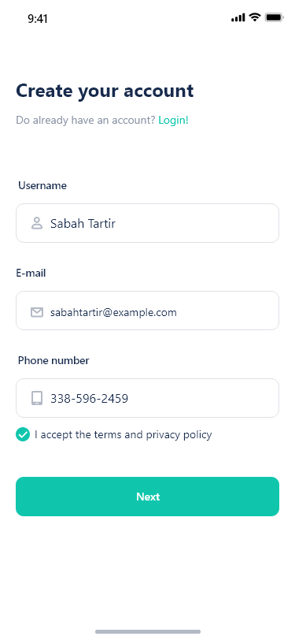

**After creating an account**, The application sends a confirmation code to the user's e-mail ,and it requests permission from the user to access his data.

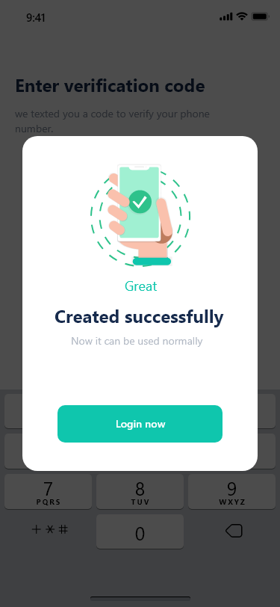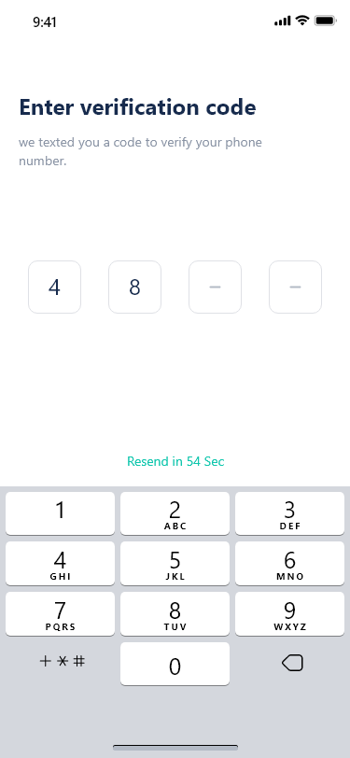

* **Login:**

When logging in, the user is able to choose the color of the application.

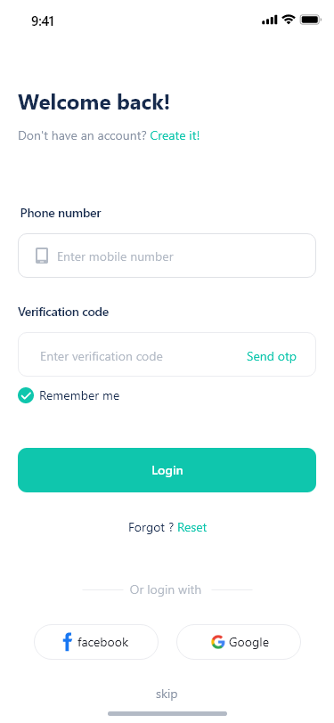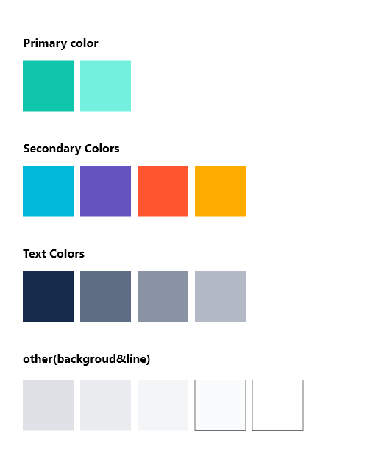

* + **Home page:**

The home page enables the user to access all the features of the application in a direct way, and we will explain each feature and how to use it.

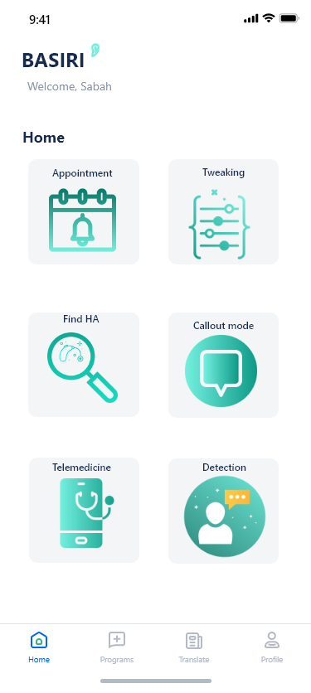

* **Notification**

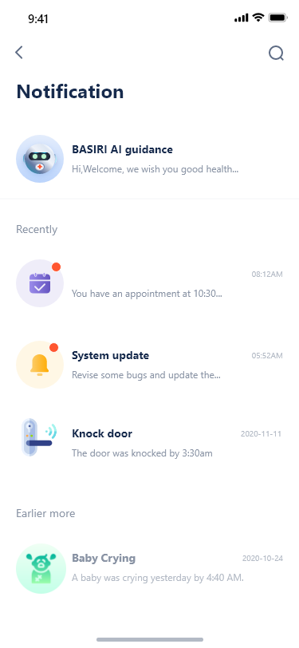

* **Setting:**

Like any other application, BA-Siri gives the ability to edit personal information and manage some of the application's features, such as notification controls, the application regularly push alerts to the user's device, but there are ways to minimize disruption and still stay in the loop. The settings also allow the user to detect his hearing aid, so that it is connected to the application to be controlled through it. And through the settings as well, the user can access the “status of the hearing aids” .

* **status of the hearing aids**

shows the connection status of the hearing aid, and the amount of charge its battery.

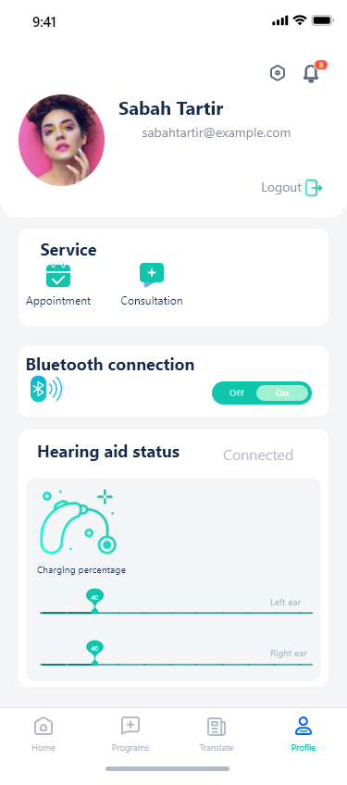

* + **HA-Supplement:**

When the user selects this feature, a map will appear showing the Audiology clinics near him, information about each clinic, working hours, distance from the place, etc.

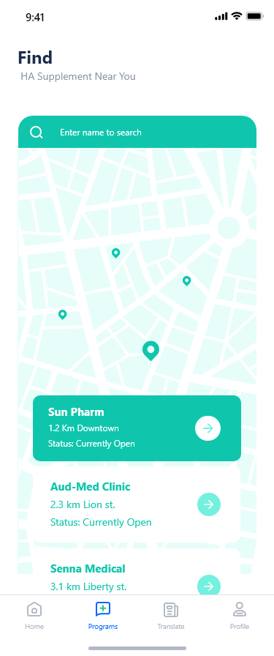

* **Frequency Tweaking**

The user chooses the frequency he wants to optimize.

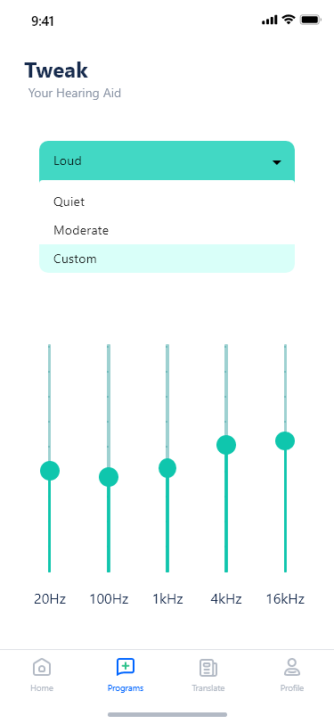

* **Detection of a new voice to use And determine the sound that we want to detect from the outside.**

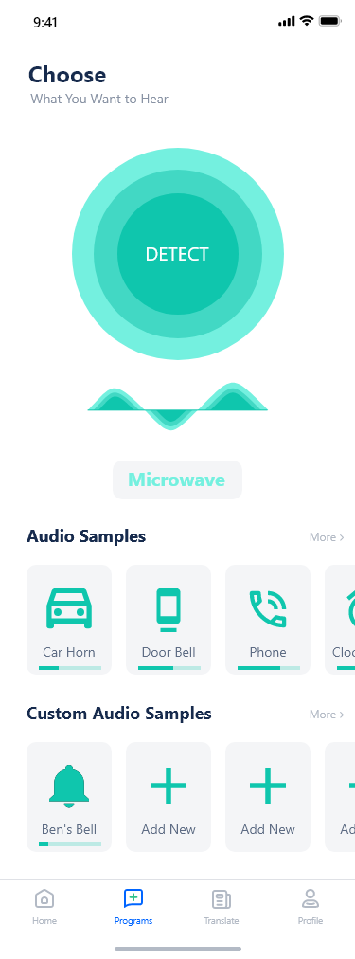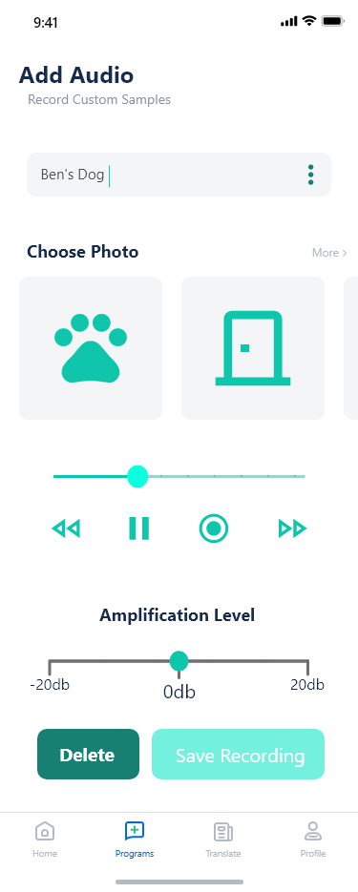

* **Callout signaling:**

To grab the attention of individuals, using either samples from the included audio library, text-to-speech, or record samples as needed, with adjustable volume displayed as radius. With the possibility of specifying how far we want the sound to reach.  
This is a useful feature for people who have difficulty speaking.

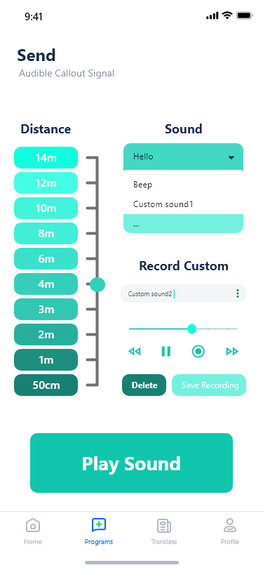

* **Ttranslation:**

The user chooses the feature he wants to turn on, for example searching by detecting sign language.

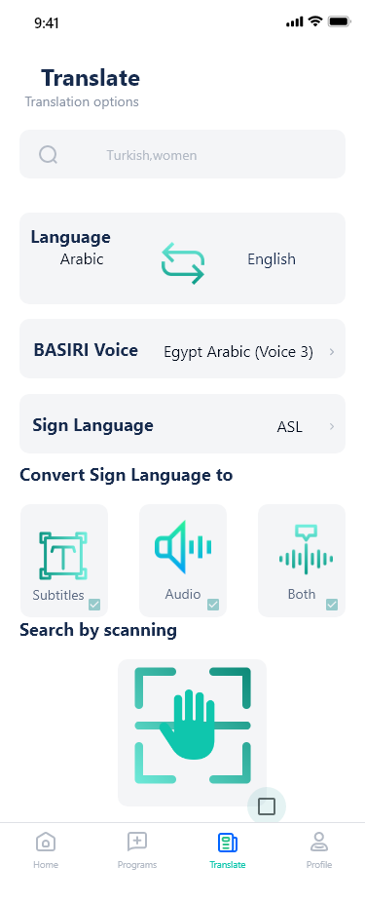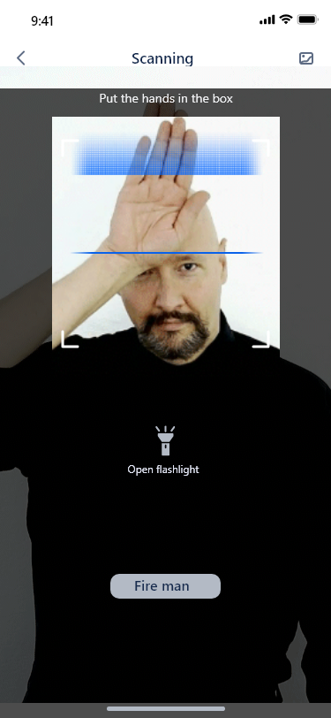

* **Programs:**

Choose the appropriate mode for the situation.

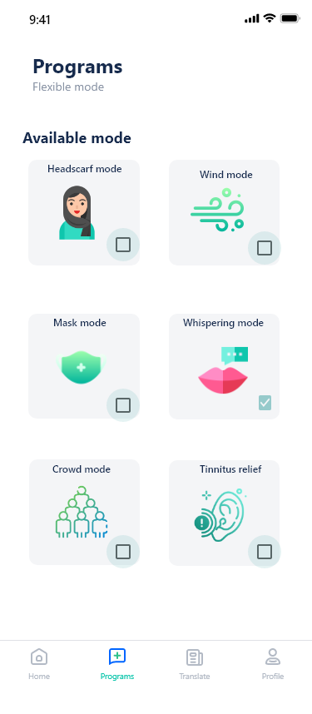

* **AI Guide:**

This feature is used by texts

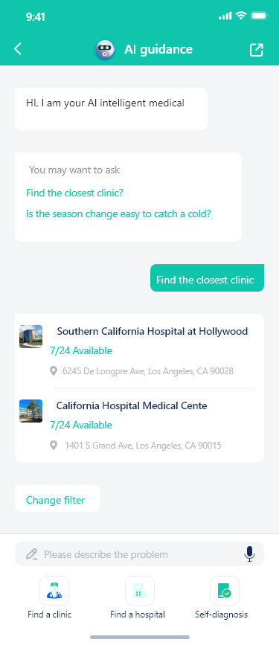

* **Searching for an Audiologist**

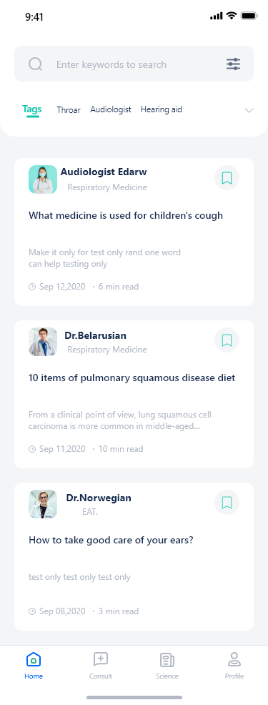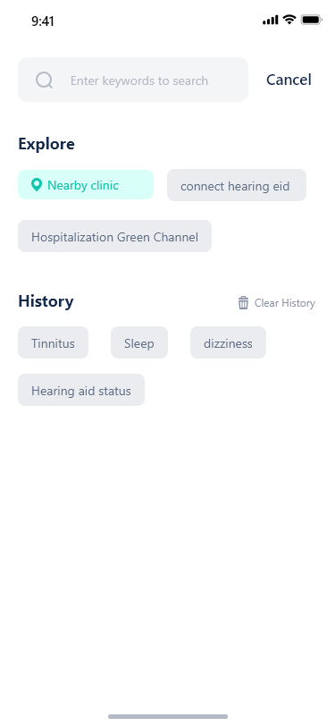

* **Choosing an Audiologist to schedule appointments**

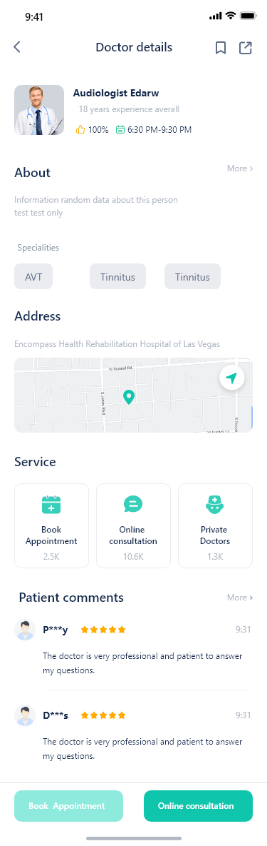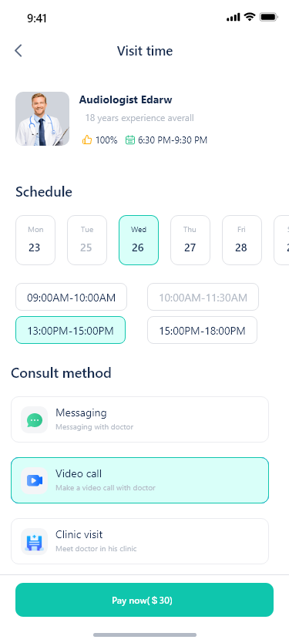

* **Fill out all the details and pay**

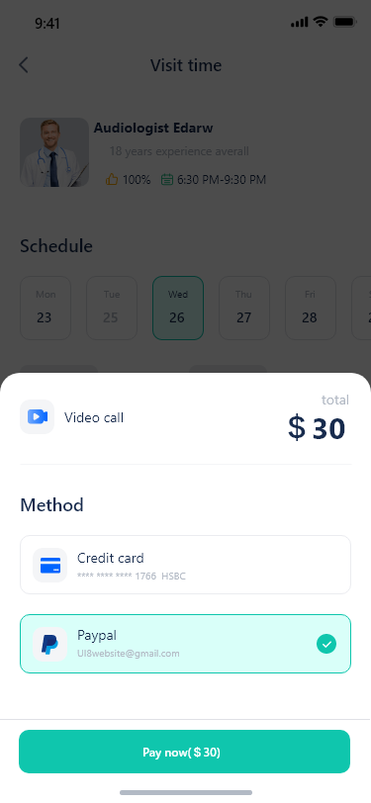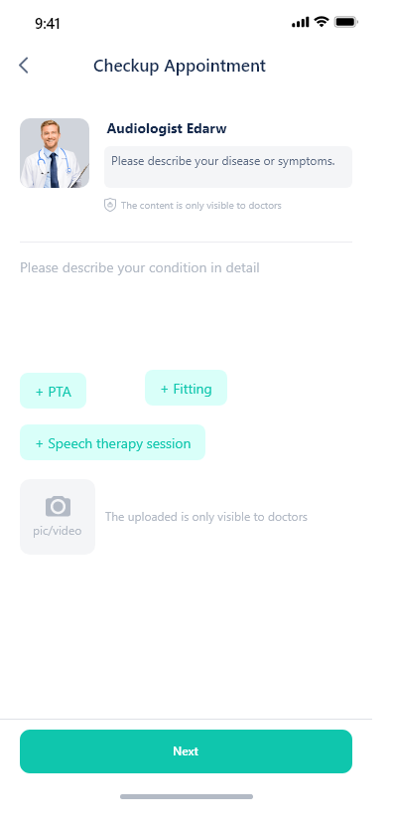

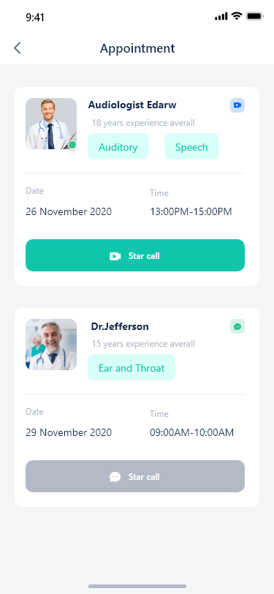

* **Determining the level of satisfaction and understanding in the video call**

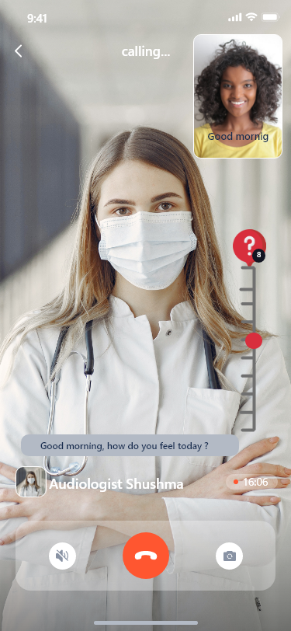

**difficulties and challenges**

Creating an application that serves people with hearing difficulties was not as easy as we expected, because they experience and navigate the world much differently than those with perfect hearing.

in order to provide something to help them we had to understand the difficulties they may face, the challenges they go through in their daily lives, as well as their needs and desires.

And after deep research, we realized that there are many situations that we have never thought of that make life more challenging when little to nothing is audible.

We also faced difficulty while designing the application to be friendly to the largest number of users.

**Go-To-Market:**

BA-SIRI is a scalable application that all hard of hearing people can use regardless of language and country.

**Reference:**

1. *Deafness and hearing loss*. (2021, April 1). World Health Organization. https://www.who.int/news-room/fact-sheets/detail/deafness-and-hearing-loss
2. World Health Organization. (n.d.). *World Report on hearing*. World Health Organization. Retrieved March 4, 2022, from https://www.who.int/teams/noncommunicable-diseases/sensory-functions-disability-and-rehabilitation/highlighting-priorities-for-ear-and-hearing-care
3. Grundfast, K. M., & Liu, S. W. (2017). What Otolaryngologists Need to Know About Hearing Aids. *JAMA otolaryngology-- head & neck surgery*, *143*(2), 109–110. <https://doi.org/10.1001/jamaoto.2016.3416>
4. D’Onofrio, K. L. (2022). *Tele-Audiology: Current State and Future Directions*. Frontiers. <https://www.frontiersin.org/articles/10.3389/fdgth.2021.788103/full#B6>
5. Noblitt, B., Alfonso, K. P., Adkins, M., & Bush, M. L. (2018). Barriers to Rehabilitation Care in Pediatric Cochlear Implant Recipients. *Otology & neurotology : official publication of the American Otological Society, American Neurotology Society [and] European Academy of Otology and Neurotology*, *39*(5), e307–e313. <https://doi.org/10.1097/MAO.0000000000001777>
6. Toscano, J. C., & Toscano, C. M. (2021). Effects of face masks on speech recognition in multi-talker babble noise. *PLOS ONE*, *16*(2), e0246842. <https://doi.org/10.1371/journal.pone.0246842>